**Image quantization project**

**Milestone one documentation**

**Team 100**

Ahmed Samir Fathy (section 2)

Ahmed Samir Mohamed (section 2)

Mohamed Adel Fathi (section 14)

Yahia Ramadan Mahrous (section 20)

Mohamed Magdy Abdelmajeed (section 14)

Rahma Ibrahim Ahmed (section 7)

**Used structures:-**

Vertix data : is a structure we built to know the node data ( RGP content , parent node , distance between the parent and the node itself , position in the heap).

Used objects :

Used Classes and it’s functions are after the functions implementation

Used Functions :-

1-distinct colors:

Code:

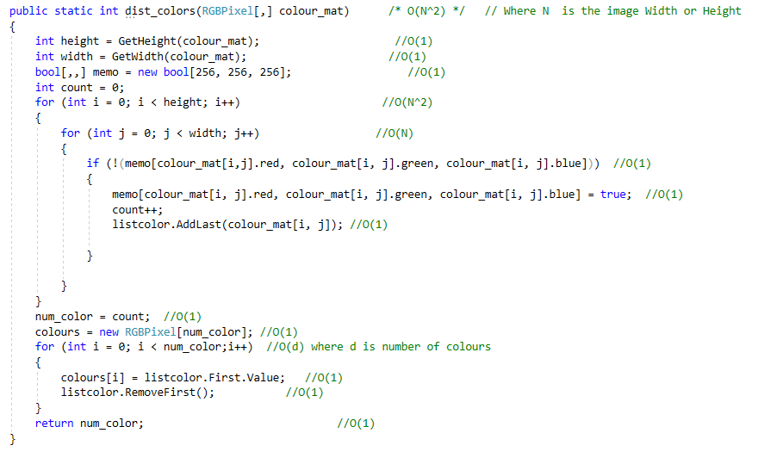

Explanation:

This function is used to determine the number of distinct colors in the image , by using histogram for checking and LinkedList to store and determine the colors without repetition then save them in array .

**Analysis of the code:-**

**O(N^2).**

2-Eclidean distance :

Code:

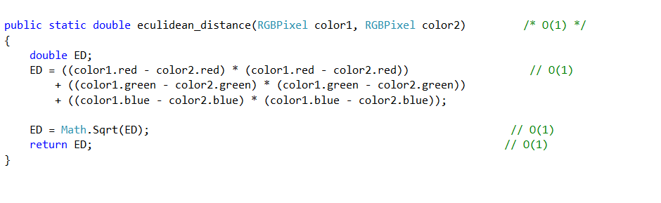Explanation**:**

Calculates the weight of the edge between two vertices and implementing the eqn :-

**Weight =sqrt ( (R2-R1)^2 + (G2-G1)^2 + (B2+B1)^2 ).**

**Analysis of the code:-**

**O(1).**

**3-MST:-**

**Code:**

Explanation:

Building the Minimum Spinning Tree Using Prim's algorithm and binary heap .

**Analysis of the code: -**

O(E log(V)).

Used Classes :-

Binary Heap

Functions in the heap : -

